Science Study Guide for Chapter 6
Weather Patterns-Test on Thursday, Dec. 7th
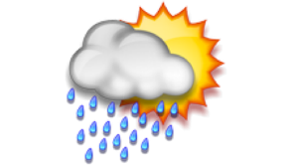
- Know all the vocabulary: climate, water cycle, atmosphere, precipitation, severe weather, weather, condensation, evaporation, storage.
- Know the difference between weather and climate
- Know all parts of the water cycle and be able to label them in a diagram
- Know all forms of precipitation
- Be able to explain the similarity between a hurricane and a tornado as well as a difference.
- Know why the sun is an important part of the water cycle!
- Be able to list two things that affect climate. (ocean, landforms, altitude)
- Be able to look at a chart and answer questions about the weather.
- Be able to identify what each of the following tools measure…. (thermometer, rain gauge, wind vane, barometer, hygrometer, anemometer)
- Be able to identify thunderstorm safety as well as tornado safety procedures.

Science Study Guide for Chapter 6
Weather Patterns-Test on Thursday, Dec. 7th
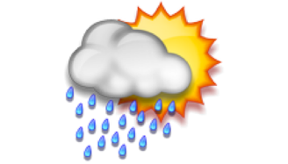
- Know all the vocabulary: climate, water cycle, atmosphere, precipitation, severe weather, weather, condensation, evaporation, storage.
- Know the difference between weather and climate
- Know all parts of the water cycle and be able to label them in a diagram
- Know all forms of precipitation
- Be able to explain the similarity between a hurricane and a tornado as well as a difference.
- Know why the sun is an important part of the water cycle!
- Be able to list two things that affect climate. (ocean, landforms, altitude)
- Be able to look at a chart and answer questions about the weather.
- Be able to identify what each of the following tools measure…. (thermometer, rain gauge, wind vane, barometer, hygrometer, anemometer)
- Be able to identify thunderstorm safety as well as tornado safety procedures.

